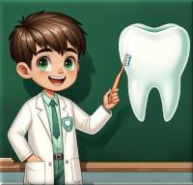
LITTLE DENTIST'S EDUCATIONAL POST
Edson Laranjeiras - September 24, 2026 at 6:01 PM
TITLE: WHAT IS GINGIVITIS?
LEARN HOW TO RECOGNIZE, PREVENT, AND MANAGE THIS COMMON EARLY STAGE OF GUM DISEASE.

What gingivitis means
Gingivitis is inflammation of the gums, usually caused by plaque—a sticky layer of bacteria that builds up on teeth.
It is the earliest and most reversible form of gum disease. Without care, it may progress to periodontitis, a more serious infection that can damage the tissues and bone supporting the teeth.
Common signs
- Red or swollen gums.
- Bleeding when brushing or flossing.
- Tender or sensitive gums.
- Bad breath.
- Gums that look shiny or pull slightly away from the teeth.
Gingivitis can sometimes occur without pain, so regular dental check-ups are important.
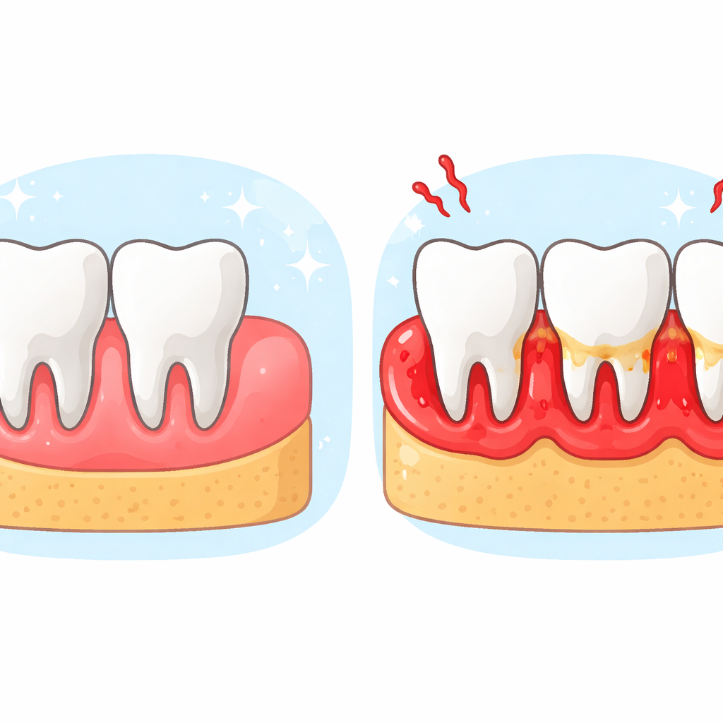
A clear educational illustration showing healthy pink gums beside red. Swollen gingivitis-affected gums. With no written text
Common causes and risk factors
- Inadequate brushing and cleaning between teeth.
- Plaque and tartar buildup.
- Smoking or tobacco use.
- Hormonal changes, such as during puberty or pregnancy.
- Diabetes and some other health conditions.
- Dry mouth or certain medicines.
How to help prevent it
- Brush twice a day with fluoride toothpaste.
- Clean between your teeth daily with floss or another suitable interdental cleaner.
- Have regular dental check-ups and professional cleanings when recommended.
- Avoid tobacco products.
- Eat a balanced diet and limit frequent sugary snacks and drinks.
If your gums bleed, gentle daily cleaning is still important. Bleeding may improve as plaque is removed, but persistent bleeding should be checked by a dental professional.
When to seek dental advice
Arrange a dental visit if bleeding, swelling, bad breath, or gum tenderness continues, or if you notice loose teeth, pus, severe pain, or gums pulling away from the teeth.
This material is educational and does not replace a professional consultation.

